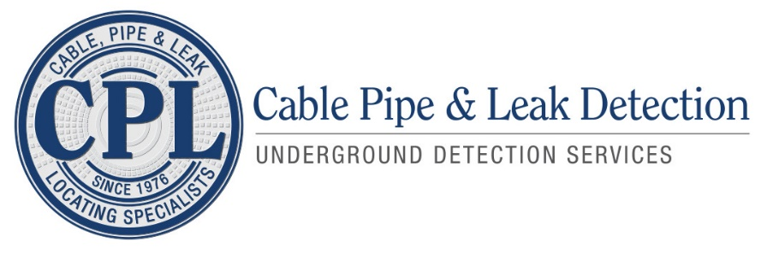
Cable Pipe and Leak Detection is the leading water leak detection and utility locating company serving all of San Diego County for over 45 years. Business is growing and we are adding the right people to our team. Our unique and specialized work involves locating underground slab leaks, outside water leaks, and locating underground utilities, all while maintaining a high level of customer service and professionalism.
We are looking for a knowledgeable Certified Payroll Specialist to process and manage the company’s certified and prevailing wage processes and data. You will be the one to calculate wages based on hours worked and administer payments. A payroll specialist is able to use payroll software with accuracy and efficiency. They are good with numbers and can be trusted with sensitive information. They have great communication skills to interact with colleagues and executives. The goal is to ensure personnel receives the correct compensation in a timely manner.
Responsibilities
- Gather information on hours worked for each employee
- Calculate the correct amount incorporating overtime, deductions, bonuses, etc. with the assistance of a computer system
- Prepare and execute pay orders through an electronic system
- Administer statements of payment to personnel either electronically or on paper
- Keep track of hourly rates, wages, compensation benefit rates, new hire information, etc.
- Address issues and questions regarding payroll from employees and superiors
- Prepare reports for upper management, finance department, etc.
Skills
- Proven experience as a payroll specialist or payroll manager
- Solid understanding of accounting fundamentals and payroll best practices
- Very good knowledge of legislation and regulations in the field
- Trustworthy with attention to confidentiality
- Outstanding organizational ability with great attention to detail
- Excellent communication skills
- High school diploma or equivalent; BSc/BA in business, accounting, or relevant field is a plus
We are currently seeking ​a Certified Payroll Specialist to join our team. Experience in Certified Payroll is required, along with state and federal prevailing wage processes. Proficiency in LCP Tracker, Emars, and Prism is highly desired. Familiarity with PSA/PLA reporting requirements is also desired. While the position has these key responsibilities, customer service and job scheduling for the Utilities Department will also be required.
The position will report to the Company Project Manager and work alongside the Project Coordinator.
Email your resume for consideration to jobs@cpldetection.com

